# Title

Towards Linear-time Incremental Structure from Motion

# Needs

The previous method has been able to more completely reconstruct the 3D scene, but there are still deficiencies:

* When more and more cameras are added, the SfM method will be significantly slower.
* The repeated scene structure will produce many wrong matches, which will affect the accuracy of scene reconstruction.
* Since the general image contains thousands of features, feature matching is still a very time-consuming step in SfM. For n input images, it takes $n^{2}$ time for complete pair matching

# Objectives

Make some improvement with the current algorithms and introduce new algorithms to reduce the complexity of SfM framework, which greatly improve the efficiency and performance of 3D reconstruction technology, while retaining high accuracy.

# Methodology

1. Preemptive Feature Matching: Since many pictures in a large-scale scene have many redundant views and feature points, authors designed a preemptive feature matching strategy that can match pictures that are most likely to be matched, to improve the matching speed.

The paper found that when important features are detected, the probability that a match is worth to be retained next is inversely proportional to the maximum number of feature points in these two matching images.

Main ideas：

- Sort the feature points in each picture by decreasing scale

- Skip scanning pictures with matching points less than a certain threshold

1. For Bundle Adjustment, VisualSFM uses the GPU version of multicore bundle adjustment to minimize reprojection errors, reducing the time spent in the bundle adjustment process from $n^{4}$ to n.

# Results

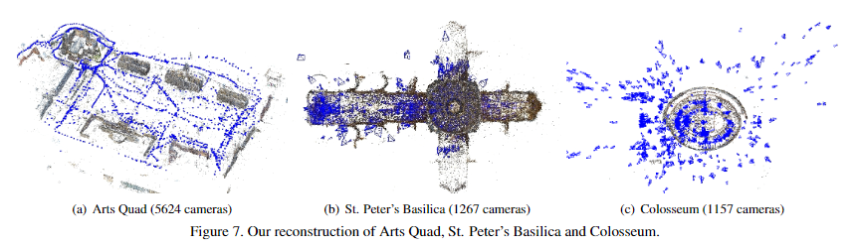

* 15065 camera model of Central Rome on an aerial image
* More precise: The average error is 2.5 meters, and the median error is 0.89 meters, which is smaller than the previous methods.
* Faster: 3D reconstruction speed is tens of times faster than the previous method, even if the performance of the test equipment used is far below

# Conclusion

In the paper, on the one hand, the SfM framework is discussed in detail. On the other hand, an improvement to Bundle Adjustment (BA) optimization is introduced, and a preemptive matching method is proposed, which greatly reduces the time complexity of feature matching cost in SfM framework.